# Homework #2: Mastering the Basics of SQL Server 2016

|  |
| --- |
| * This is an individual assignment, and is worth 20 points. * The due date is 2:30 (sec 01) / 5:30 (sec 76) on Tuesday, January 30th 5:30 pm. * You have to use the “Homework #2-Tasks.docx” file to provide your answers. Change this file name according the naming convention below. * Use the following naming convention: homework, underscore, last name, first initial, and extension (e.g., Homework #2_ImG.docx). If you do not follow the convention, I will deduct 1.0. * Do not copy any of the sample screenshots provided as illustrations. * Report any issues before the deadline. |

(**Task 1: 5 points**) Complete Task #2 through Task #4 while placing your sql files in Queries. Show in a screenshot that your Homework 2 project in Solution Explorer contains **three** sql files in **Solution Explorer**.

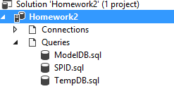

**(Task 2: 5 points**) Show in a screenshot that **DatabaseLog_test** table is created in **MySecondDatabase**, and **not** in **MyFirstDatabase**.

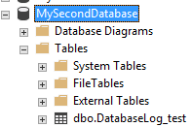

(**Task 3: 4 points**) Create the three temp tables listed above and show their existence using the SELECT command above. Attach a screenshot.

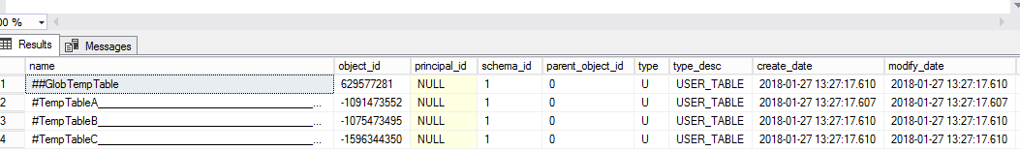

(**Question: 1 points**) When do we use temporary Tables? List three scenarios. When do we use table variable over temp table? For the answers, go to the link above.

1. When we are doing large number of row manipulation in stored procedures.
2. This is useful to replace the cursor. We can store the result set data into a temp table, then we can manipulate the data from there.
3. When we are having a complex join operation.

Table variable is always useful for less data. If the result set returns a large number of records, we need to go for temp table.

(**Task 4: 5 points**) Fill in **all** the blanks. Keep in mind that you have made a connection via a dynamic port not the default number. Your answers to the second column must be consistent with the connection you made.

|  |  |  |
| --- | --- | --- |
|  | **Name/Number** | **Description (definition)** |
| SPID | 53 | They are essentially sessions identifiers in SQL |
| SID | 0x0105000000000005150000007F4431C908D0373ED477057CE903000000000000000000000000000000000000000000000000000000000000000000000000000000000000000000000000000000000000000000000000 | Identifies the security context of the login |
| principal_id | 259 | Identifies as securable within the server. Created when login is executed |
| net_library | TCP/IP | Defines the type of connection ex. TCP/IP, default |
| local_tcp_port | I used 49496 because an error occurred when I used port 49214. It would say the connection could be established but there was an error during handshaking. | The port you use to establish the local connection to the SQL server |

In addition, show the result of each of the four queries in a screenshot.

